**Exercise 2: Implementing Dependency Injection**

**Step 1: Modify applicationContext.xml**

We’ll wire (inject) the BookRepository into BookService using Spring's XML <property> tag.

Updated XML Configuration:

Ensure your file at src/main/resources/applicationContext.xml looks like this:

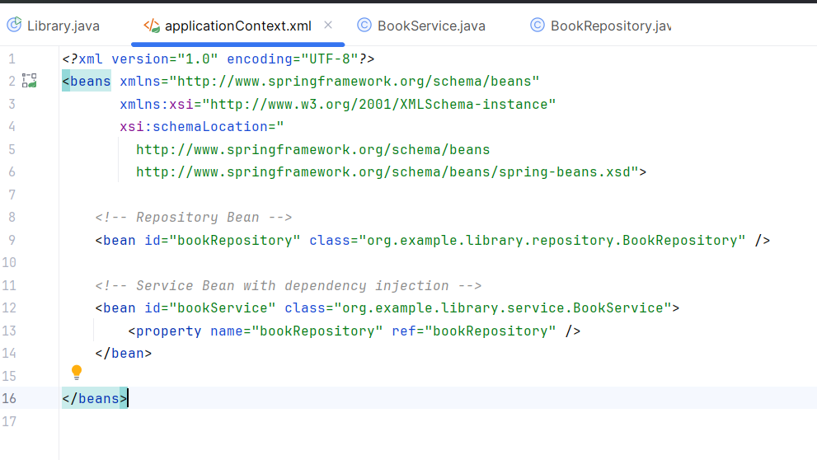

**Step 2: Update BookService.java**

We provide a setter method so Spring can inject BookRepository into BookService.

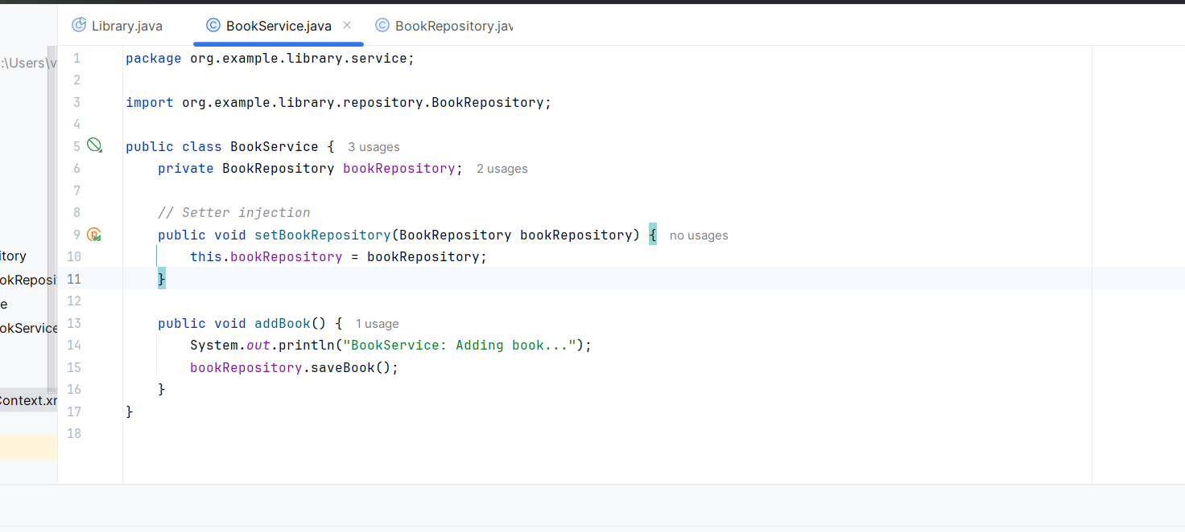

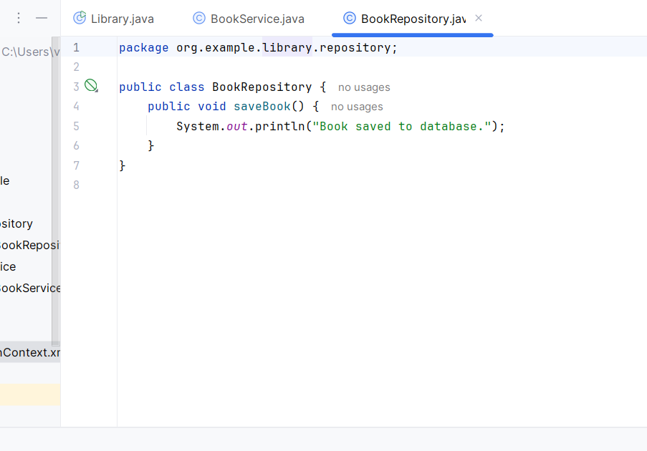

**Step 3: Test the Configuration**

We run the application and verify that Spring successfully injected the dependency.

